Name___________________________________

Quick Quiz

**Unit Rate 10**

Identify the unit rate:

1. run 2 miles in 26 minutes 2. $y=\frac{3}{4}x$

**_________ minutes per mile unit rate =_________**

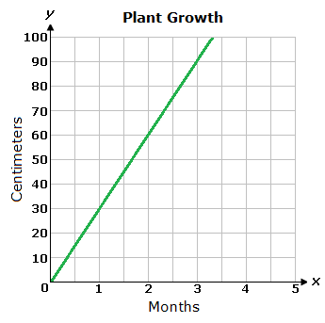

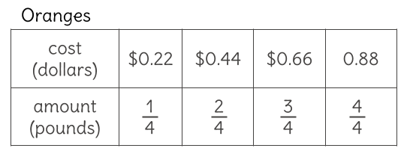3. 4.  **________**

**centimeters per month**

**$________ per pound of oranges**

____________________________________________________________________________

Corrections

**Unit Rate 10**

Identify the unit rate:

1. run 2 miles in 26 minutes 2.

**_________ minutes per mile unit rate =_________**



3. 4.  **________**

**centimeters per month**

**$________ per pound of oranges**